ST. XAVIER’S COLLEGE

(Affiliated to Tribhuvan University)

Maitighar, Kathmandu



**Computer Network Lab Assignment #3**

**SUBMITTED BY:**

Pradeep Dahal

017BSCIT029

2nd Year/4th Sem

|  |  |
| --- | --- |
| **Mr. Sanjay Kumar Yadav**  **(Lecturer)** |  |
| **Department of Computer Science** | |

**OBJECTIVE: IMPLEMENTATION OF DHCP SERVER**

**REQUIREMENTS:**

1. CISCO Packet Tracer
2. Server
3. Router
4. End devices
5. Copper Straight-Through Cables

**THEORY:**

DHCP (Dynamic Host Configuration Protocol) is a network management protocol used to dynamically assign an Internet Protocol (IP) address to any device, or node, on a network so they can communicate using IP. DHCP automates and centrally manages these configurations rather than requiring network administrators to manually assign IP addresses to all network devices.

A DHCP Server is a network server that automatically provides and assigns IP addresses, subnet mask information, default gateway IP addresses and domain name system (DNS) addresses to its clients. It relies on the standard protocol known as Dynamic Host Configuration Protocol or DHCP to respond to broadcast queries by clients. A DHCP server automatically sends the required network parameters for clients to properly communicate on the network. Without it, the network administrator must manually set up every client that joins the network, which can be cumbersome, especially in large networks. DHCP servers usually assign each client with a unique dynamic IP address, which changes when the client’s lease for that IP address has expired.

**PROCEDURE:**

Step 1: Start CISCO Packet Tracer and create a network as shown below:

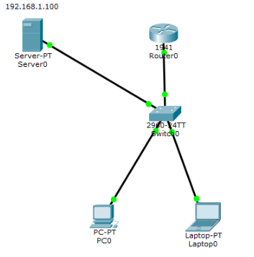

Step 2: Configure router basics.

* Enable the router
* Go to the configure section and change the hostname as required by the user
* Configure the IP address and subnet mask for the router to act as the default gateway for our LAN.
* Exit

A screenshot of a cell phone

Description generated with high confidenceA close up of a screen

Description generated with high confidence

A screenshot of a cell phone

Description generated with very high confidence

Step 3: Configure DHCP server on the Router. In the server, define a pool of IP addresses to be assigned to hosts, Default gateway and a DNS Server.

A screenshot of a cell phone

Description generated with very high confidence

Step 4: IP Configuration of the server:

A screenshot of a cell phone

Description generated with very high confidence

Step 5: Now go to every PC and on their IP configuration tabs, enable DHCP. Every PC should be able to obtain an IP address, default gateway and DNS server.

For example, to enable DHCP on PC0:

Click PC0->Desktop->IP configuration. Then enable DHCP:

A screenshot of a social media post

Description generated with very high confidence

**CONCLUSION:**

Hence by using the CISCO Packet Tracer, we implemented DHCP Server and automatically provides and assigns IP addresses, subnet mask information, default gateway IP addresses and domain name system (DNS) addresses to its clients.